Diabetic Retinopathy detection using Deep Learning

Contents:
- Problem Definition and Objective
- Dataset preparation
- Model Development
- Training and Evaluation
- Grad-CAM visualization
- Prediction pipeline
- Web Application integration
- Future scope
- Conclusion

Problem Definition and Objective
Diabetic Retinopathy is an eye condition which can cause vision loss and blindness in people who have Diabetes. It affects blood vessels in the retina. If we have diabetes, it is important to get dilated eye exam every year. DR may not have symptoms at first but finding it early can help us protect our vison. The early stage of DR doesn’t have any symptoms, some people notice changes in their vision, but these changes can come and go…
Symptoms of DR include lack of vision at night, seeing floating spots, blurred vision.
Anyone with any kind of diabetes can get DR like even people with Type 1 and Type 2 and gestational diabetes (diabetes which can develop during pregnancy).
The risk of getting DR increases with the time we have diabetes. DR is caused due to high blood sugar levels in people with diabetes. So, basically there are two main stages in Diabetic Retinopathy:
- Non-proliferative DR
- Proliferative DR
Non-proliferative diabetic retinopathy (NPDR) is early stage of the disease in which the symptoms are mild or almost nonexistent. It is further divided into three stages they are
- Mild: A few microaneurysms (small bulges in blood vessels of retina)
- Moderate: At this stage the blood vessels in retina swell and blood, other fluids build up in a part of our retina called Macula.
- Severe: In this stage blood vessels gets more blocked. So less blood goes to retina, this lack of blood triggers new blood vessel formation.
Proliferative diabetic retinopathy (PDR) is an advanced stage in DR where new blood vessels grow in our retinas and into the gel like fluid which fills our eyes. But these new vessels are thin and weak, they often bleed. This bleeding can cause Scar tissue.

Our objective for this project would be to detect the stage of diabetic retinopathy in which the patient’s retina is in. The goal could be boiled down to a simple image classification problem. But handling with complex images like retinas where even minute details matter is a tough thing to work with. The expected application should take a retina image and tell us the DR stage and give some suggestions and also the application should be explainable.

Dataset Preparation
The backbone of any automated detection model whether ML-based, DL-based, or multi-model-based, is the dataset. We explored several online sources, including Kaggle, IEEE Dataport, and public ophthalmology archives, to find the most suitable dataset for our project and we eventually decided on going with a Kaggle dataset. There were tons of datasets on this problem the dataset sizes ranging upto almost 10gb!! As this is a prototype model we thought of training on a medium level dataset as the large datasets consume more time and GPU power to train. So we ended up choosing the dataset made by Sovit Ranjan Rath. It was a dataset of 1gb and it contained one folder and a CSV file named “train.csv”. The folder contains subfolders with the images of retina with respect to their stages. The images were 224 x 224 pixels and gaussian filtered.
After evaluation, we chose the dataset “Diabetic Retinopathy 224 x 224 Gaussian Filtered” created by Sovit Ranjan Rath. This dataset is approximately 1 GB in size and comes well-structured, containing one main folder with subfolders corresponding to each diabetic retinopathy stage, and a CSV file named train.csv that maps every image to its respective label (0–4). Each numeric label corresponds to a particular stage of the disease:
- 0 → No Diabetic Retinopathy
- 1 → Mild
- 2 → Moderate
- 3 → Severe
- 4 → Proliferative DR
This dataset helped us in reducing some amount of work like we wanted to use EfficientNetB0 in this project, and EfficientNetB0 takes 224 x 224 pixes so this dataset was the perfect fit for our needs to train the model on.
The dataset contains 3,662 fundus images. It seems like a large number but it is really less for a deep learning model. For a DL models tend to perform best with thousands of data items.
To summarize, this dataset not only matched our model’s input requirements but also provided prefiltered, clean and well labelled data, making it an ideal choice for developing this project.

Model Development
At this stage we wanted to build an idea on what model is best for making our project work.
There were many choices like VGG-16, MobileNet-v2, Efficient-b0, Inception-v3, ResNET-50, and GoogLeNet. But we needed a model which would be light weight and efficient. But it should also work well on smaller datasets. According to a research article from Frontiers, they trained different models on APTOS 2019 and Efficient-b0 showed the highest classification rate of 82.4% (kappa value = 0.73), with almost 162 min 6 s training time, and also has 4 million learnable parameters. The second best is the Inception-v3 model with 81.86% classification accuracy (kappa value = 0.72), 110 min 17 s training time, and 21.8 million learnable parameters.

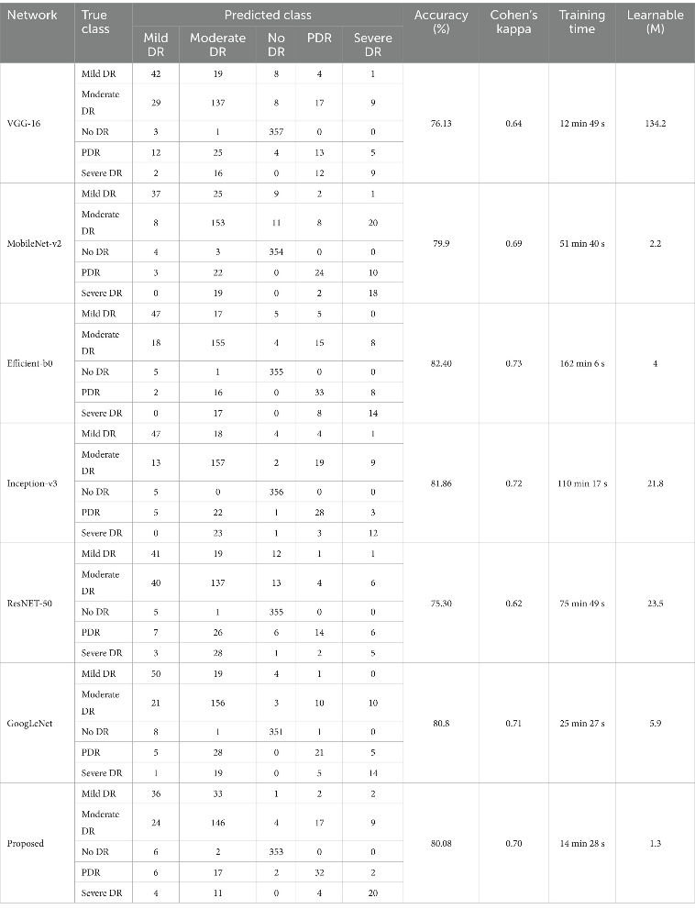

Considering the research and evaluations from the article, we proceeded on to work on our project with this model.

Efficientnet Architecture
EfficientNet is a family of CNNs which aims to achieve a high performance with fewer computational sources compared to previous architectures. So the core idea of this model is a new scaling method which uniformly scales all the dimensions of depth, width and resolution using a compound coefficient.
EfficientNet-B0 can be divide into three main parts:
- Stem : Initial layer with Standard convolution followed by batch normalization and
ReLU6 as activation
- Body : Body consists of MBConv blocks with different configurations. Each block
includes depthwise seperable convolutions and S&E layers.
- Head : It contains the final convolution block, followed by a global average pooling layer and a fully connected layer with SoftMax activation function for classification
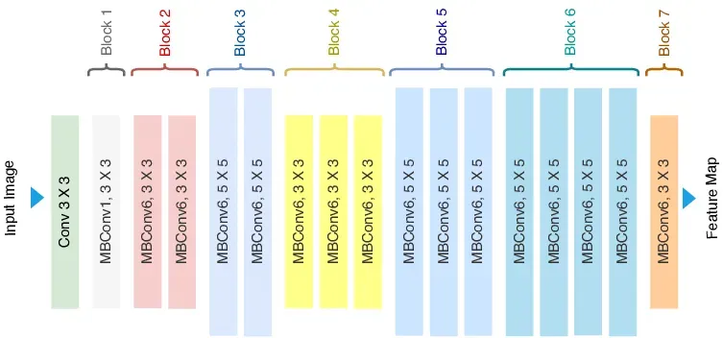
EfficientNet Architecture
EfficientNet achieves state-of-the-art accuracy on ImageNet with significantly fewer parameters and FLOPS compared to previous models like ResNet, DenseNet, and Inception. Due to the balanced scaling method, EfficientNet models provide an excellent trade-off between accuracy and computational efficiency, making them suitable for deployment in resource-constrained environments.

Training and Evaluation
The goal of this phase was to train the EfficientNetB0-based model on the preprocessed dataset and evaluate its ability to correctly classify retinal images into their respective DR stages.
Libraries used :
- Building CNN model : Pytorch
- Visualizations : Matplotlib
- Image Processing : PIL
- Data transformation : Numpy
- CSV file processing : Pandas
- Preprocessing : Scikit-Learn
The training flow basically goes in the following steps
- Importing Necessary Libraries
All essential Python libraries such as torch, torchvision, numpy, pandas, and matplotlib are imported for model building, data handling, and visualization.
- Dataset Loading and Preprocessing
The dataset (fundus images and corresponding labels) is read using pandas and split into training and validation sets.
Each image is resized to 224×224 pixels, converted to tensors, and normalized according to EfficientNet’s ImageNet preprocessing standards.
- Data Transformation and Augmentation
Data augmentation (like rotation, flipping, zoom, brightness adjustment, etc..) is applied to the training set to artificially increase data diversity and prevent overfitting.
- Model Initialization and Training
The EfficientNetB0 model (pretrained on ImageNet) is initialized, with the final classification layer modified for 5 output classes. The model is trained using the Adam optimizer and CrossEntropy loss with class weights to handle class imbalance. Training involves forward propagation, loss computation, backpropagation, and weight updates.
- Validation and Model Saving
After each epoch, the model’s performance is evaluated on the validation set. The version of the model achieving the highest validation accuracy is saved as the best checkpoint.
- Performance Visualization
Training and validation accuracy/loss are plotted using Matplotlib to analyze the model’s learning behavior and convergence.
A batch of 16 is sent into the model as input. The model is trained for 30 epochs for the frozen base and another 10 for fine tuning.
We used some Callbacks like ModelCheckPoint, EarlyStopping, ReduceLROnPlateau. So, basically ModelCheckPoint saves the best weights based on validation accuracy, EarlyStopping as it’s name says it stops training process when model is overfitting and ReduceLROnPlateau reduces learning rate when validation loss stays the same. This helped the model become robust to variations in image orientation and scale. Sample weights are used in the generator to apply class weights for each batch. For better and faster run time we switched our training to Google Colab, because they offer a free GPU which is makes the training faster. Workspace was created on Colab and the training run for around 35 minutes. This yielded pretty bad results. We also added plots in our train file to monitor the Loss vs Accuracy curves on both training and validation set.
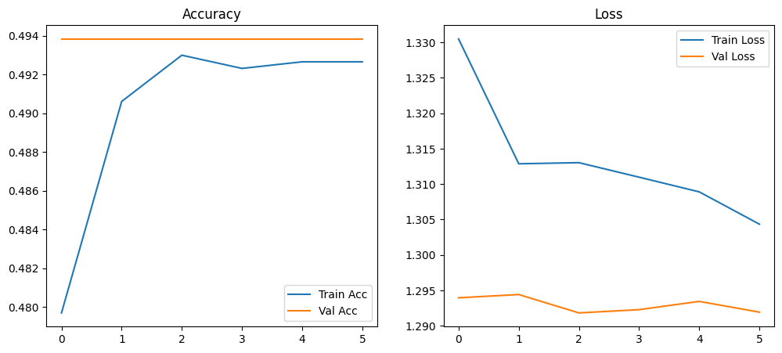
This was the Loss and Accuracy change curves for the first train. The accuracy increased up to 49% in training set but it stagnated at around 50% for the validation set. On the other hand, the loss decreases up to 1.3 in training set and fluctuates in validation set.
The likely causes could be due to a very low or very high learning rate and Data Imbalance. These can be fixed by setting the gradient value to be a bit higher and weighting minority classes.

